**JERSEY FRESH**

**FARM to SCHOOL WEEK**

**September 23-27, 2019**

**Nat’l Farm to School Month --- October**

[**http://www.farmtoschool.nj.gov/agriculture/farmtoschool/schools/toolkit/**](http://www.farmtoschool.nj.gov/agriculture/farmtoschool/schools/toolkit/)

**Celebrate by serving Jersey fresh APPLES in your FFVP program!**

**FRUIT & VEGETABLE IDEAS Classroom Link…**

**Quick Steps to increasing your students’ knowledge of Apples…** *Items in bold are enclosed.*

|  |
| --- |
| * Review **“Fact Sheet”** and **“Fun Facts”** *(Students make announcements on FFVP snack days)* * Have students color **“Anthony Apple”** * Have students complete **“Apple Trivia”** * Have students search for the words in **“Applerrific”** * Taste different varieties of Jersey apples * Conduct a contest --- Let students vote for their favorite variety of apples   *(Incorporate into a math lesson & let students tally, do graphs…)*   * Feature a “Wear your Favorite Apple Color Day” --- red, green, yellow/golden   *(Students wear their favorite apple color on that day)*   * Have students research different kinds of apples --- Fuji, Gala, Winesap…   *(Select students to make announcements, classroom presentations…)*   * Incorporate apple info. into a health project *(nutritional benefits of eating apples)*,   language arts class *(Write about the appearance & taste of apples)*…   * Invite a farmer to your school to discuss how apples are grown * Take students on a trip to a farm to see how apples are harvested |

**j0185604 Home Link…**

**Quick Steps to more fruits and vegetables at home …**

*Items in bold are enclosed.*

|  |
| --- |
| * **Kids’ Kitchen Recipes ---** Remind parents/guardians to try recipes with   their children! Encourage making **Apple Rings** as a family activity!   * **Recipes for Home ---** Try new **Apple Sandoodle** recipe at home! |

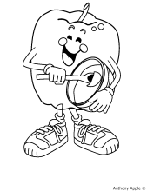**Apples**

Fact Sheet

**Where did they come from?**

Apples have been grown for over 5,000 years. Apples can be traced back to the Romans and Egyptians who introduced this fruit to the British. Early Americans brought seeds from Europe and planted the first apple trees in Massachusetts and Virginia. Johnny Chapman, more commonly known as “Johnny Appleseed”, planted apple seeds wherever he traveled in the United States. Currently, at least 50% of apples grown in the United States are fresh, while the other 50% are used for juices, applesauce, jellies or dehydrated apple products. Today, Americans eat over 120 fresh apples each, per year!

**Where do they grow?**

Apples are grown throughout the United States, but Washington State produces the most apples each year. This state produces more than half of the fresh apples grown in the country. They sell their apples to all 50 states and over 40 countries. Other states, which are top producers of apples, include New York, New Jersey, California, Michigan, Pennsylvania and Virginia. New Jersey’s leading counties that produce apples are Gloucester, Camden, Cumberland and Warren. Imported apples are grown in Canada and New Zealand. Most apple varieties are available all year round, but some varieties are only available a few months of the year.

**How do they grow?**

Commercial apples are not grown from seeds but through grafting or budding to produce trees that will bear fruit. Apple trees require fertile soil, adequate amounts of water, and grow best where the climate is hot during the day and cool at night. Once the apple tree is planted, it takes about 2-3 years for the tree to produce fruit. The apple tree will grow buds or short shoots which bloom into apple blossoms and form the fruit. When the fruit is mature and ripe, the apples are hand picked.

**Are they healthy?**

* Good source of fiber, potassium and vitamin C
* Contains no fat, cholesterol or sodium

**How do you pick a good one?**

* Choose apples that are firm
* Select ones with a shiny skin, not dull
* Avoid those with soft spots, bruises, punctures or discoloration

☺ **FUN FACTS!** ☺

**Apples**

**Did you know…**

* **Did you know one apple has 5 grams of fiber, which provides**

**20% of the daily fiber recommendation?**

* **Did you know that apples are in the rose family?**
* **Did you know that in one year, an apple tree produces enough apples to fill 20 each, 42 pound cases, of apples?**

*(One tree produces 840 lbs. of apples per year!)*

* **Did you know there are many different varieties of apples?**

*(Braeburn, Golden & Red Delicious, Fuji, Gala, Jonagold, Rome Beauty,*

*Granny Smith, Winesap, McIntosh, Pink Lady, Cameo, York, Ginger Gold,*

*Jonathan...)*

* **Did you know apples float because 25% of their volume is air?**
* **Did you know there are over 7,000 varieties of apples grown**

**throughout the world?**

* **Did you know New Jersey’s first apple seed was planted in 1639?**
* **Did you know apples can be red, green or even yellow in color?**
* **Did you know Granny Smith apples are bright green and are**

**delicious, either cooked or eaten raw?**

*(If you like tart, crispy foods --- than this apple is for you!)*

* **Did you know that you could reduce the fat and calories in**

**baked goods by substituting applesauce for shortening or**

**oil?** *(Substitute the same amount of applesauce for the shortening or oil; for*

*example, use a**½ cup applesauce instead of a ½ cup of oil. Try replacing only*

*half the amount of shortening or oil in the recipe first, to see how it turns out!)*

* **Did you know you could prevent cut, fresh apples from turning brown by dipping them in a solution of lemon, orange or pineapple juice and water?**

*(Use 1 part juice to 3 parts water as a dipping mixture.)*

Remember …

**Eat more fruits and vegetables everyday!**

**Types of New Jersey Apples**

Of the 30 different apple varieties grown in New Jersey, the Winesap is the oldest, dating back to the late 1700s. Other popular varieties grown in New Jersey include Red and Golden Delicious, McIntosh, and Granny Smith. But to give consumers a larger assortment of this popular fruit, researchers are always testing for new varieties. [**http://www.state.nj.us/jerseyfresh/appletypes.htm**](http://www.state.nj.us/jerseyfresh/appletypes.htm)

C:\Documents and Settings\agmceli\Local Settings\Temporary Internet Files\Content.IE5\36IF2I43\MC900359571[1].WMF

**JONAGOLD**

* Sweet with a hint of tartness.
* Excellent for out of hand eating,

salads, sauces & baking.

* Good for use in pies & freezing.

**JONATHAN**

* Slightly tart taste.
* Good for all-purpose use.

**MACOUN**

* Very sweet flavor.
* Excellent for out of hand eating.
* Good for sauces & salads.

**McINTOSH**

* Sweet with a slightly tart taste.
* Excellent for out of hand eating

& sauces.

* Good in salads & pies.

**RED DELICIOUS**

* Sweet taste.
* Excellent for out of hand eating

& salads.

**STAYMAN/STAYMAN WINESAP**

* Slightly tart taste.
* Good for all-purpose use.

A listing of where to find New Jersey Apples can be obtained through:

*New Jersey Apple Industry   
Advisory Council  
PO Box 330  
Trenton, NJ 08625-0330*

**CORTLAND**

* Slightly tart taste
* Excellent for eating, salads, sauces, pies & baking.
* Good for freezing.

**EMPIRE**

* Blend of sweet-tart taste.
* Excellent for out of hand eating & salads.
* Good for baking, pies, sauce & freezing.

**FUJI**

* Very sweet taste.
* Excellent for out of hand eating & salads.
* Good for sauce.

**GALA**

* Mildly sweet flavor.
* Excellent for out of hand eating & salads.

**GOLDEN DELICIOUS**

* Sweet taste.
* Excellent for out of hand eating, salads & sauces.
* Good for baking, pies & freezing.

**GRANNY SMITH**

* Tart tasting.
* Good for all-purpose use.

**Classroom Link…**  **Anthony Apple**

***From:***Dole 5-A-Day Web-Site; [www.dole5aday.com](http://www.dole5aday.com)

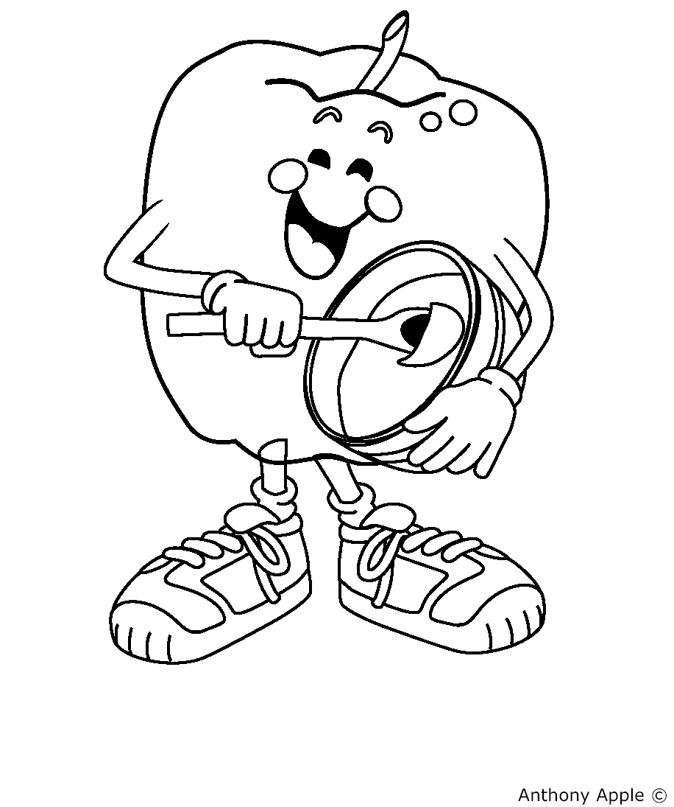

**Classroom Link…**

** **APPLE TRIVIA** **

1. **How many different apple varieties are there?**

**____15 ____7,500 ____400 ____6**

1. **Apples are harvested by?**

**____Horse ____Tractors ____People ____Helicopters**

1. **When are apples harvested?**

**____Winter ____Spring ____Summer _____Fall**

1. **How many seeds are in an average apple?**

**____5 ____1 ____3 ____16**

1. **How many grams of fiber are in an apple?**

**____1 ____3 ____5 ____12**

1. **Which state grows the most apples in the U.S.?**

**____Michigan ____Washington ____New York ____Alaska**

1. **How many fresh apples, on an average, does an American eat in one year?**

**____5 ____50 ____35 ____120**

1. **What is the most popular apple variety in the United States?**

**____Golden Delicious ____Granny Smith ____Fuji ____Red Delicious**

**Classroom Link…**

** ***APPLE TRIVIA ANSWERS***  **

**1-How many different apple varieties are there? __X__7,500**

*Only a handful are available in your supermarket!*

**2-Apples are harvested by? __X__People**

*In Washington State, workers harvest over 3 billion apples by hand each fall.*

**3-When are apples harvested? ___X__Fall**

*Apples are picked between August and early November. Advanced storage technology keeps them fresh year-round!*

**4-How many seeds are in an average apple? __X__5**

*Apples contain 5 seed pockets. Usually, each pocket contains a seed.*

**5-How many grams of fiber are in an apple? __X__5**

*A medium apple contains 5 grams, 20% of the recommended daily allowance.*

**6-Which state grows the most apples in the U.S.?**

**__X__Washington**

*This state produces 6 of every 10 apples consumed in the U.S.*

**7-How many fresh apples, on an average, does an American eat in one year? __X__120**

**8-What is the most popular apple variety in the United States?**

**__X__Red Delicious**

**Classroom Link…**

**APPLERRIFIC**

[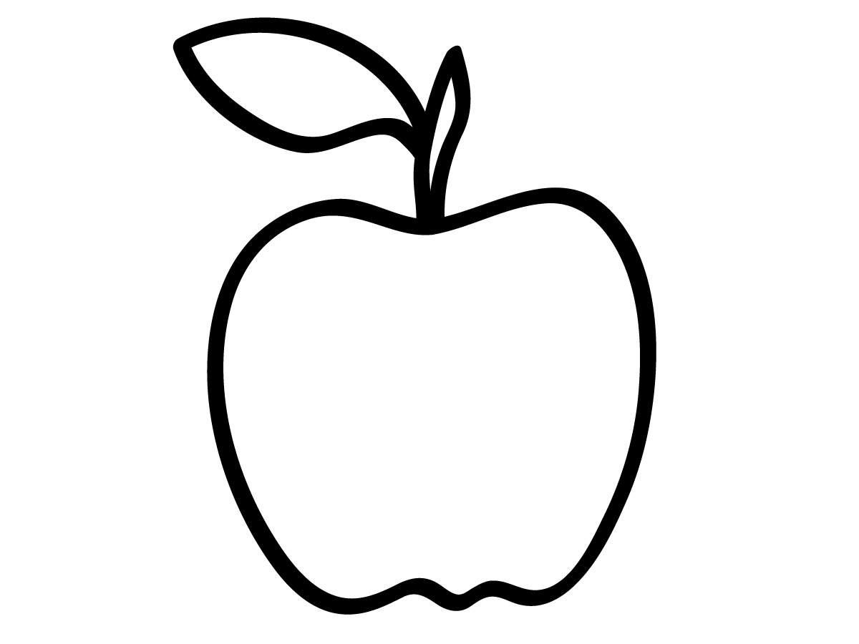](http://www.abcteach.com/free/a/apple2pbnwunlabeled.jpg)

Y R O M W I S T P P G P O O Y

H Y E F T W F L R O H I U D W

T Q Z D E N I A Y J T N Q P E

L J Q E I P N Y R S D S A E U

A U T C O C R M Q M P L B E W

E I Y L W O D M Z O E Y A R G

H C Y U T D Q W L K T R T R O

V Y B C G J Y L H A R V E S T

P H A N E T I H P S I R C J R

P R I S R N K Q C L J S Y H A

T Z D R A H C R O N X R J H T

O Z R T Q X C H D P U R U J Z

P Z I G H C U H D X N R V O V

I O T Y N X J K L J O J C E N

N E J X J Q D G R X Y F B O E

**Can you find the words hidden in the apple?**

1. **BEE 8. JUICY**

**2. CIDER 9. ORCHARD**

**3. CRISP 10.POLLINATION**

**4. CRUNCHY 11.SWEET**

**5. FARMER 12.TART**

**6. HARVEST 13.TRACTOR**

**7. HEALTHY**

**-Use these words to write a story about apples.**

**Classroom Link…**

**APPLERRIFIC**

Solution

+ H C R I S P + + + N + T + +

+ E + + + + + + + O + R + + +

+ A + + + + + + I + A + + + +

+ L + + + + + T + C + + + + +

+ T S E V R A H T + + + + T +

+ H + + + N + O + + + + E + +

+ Y + + I + R + Y + + E + + +

C + + L + + + + C + W + + + +

+ R L + + R + + I S + B + + +

+ O U C + + E + U + E + + + +

P + + N I + + M J E + + + + +

+ + + + C D + + R + + + + T +

+ + + + + H E + + A + + + A +

+ + + + + + Y R + + F + + R +

+ + O R C H A R D + + + + T +

**(Over,Down,Direction)**

**BEE(12,9,SW)**

**CIDER(4,10,SE)**

**CRISP(3,1,E)**

**CRUNCHY(1,8,SE)**

**FARMER(11,14,NW)**

**HARVEST(8,5,W)**

**HEALTHY(2,1,S)**

**JUICY(9,11,N)**

**ORCHARD(3,15,E)**

**POLLINATION(1,11,NE)**

**SWEET(10,9,NE)**

**TART(14,12,S)**

**TRACTOR(13,1,SW)**

**j0185604 Home Link…**

**KIDS’ KITCHEN **

**Apples**

**How to Cut and Slice Apples:**

1-Rinse under cold running water, but do not peel

2-Secure the apple on a cutting board

3-Cut in half

4-Slice away core and seeds

5-Place apple flat side *(flesh or white part)* down on cutting board

6-Cut fruit into desired thickness

7-Protect cut apples from turning brown by dipping them in a mixture of one part citrus *(orange or lemon juice)* and three parts water

**Fun Ways to Eat:**

* Munch on raw wedges with dip
* Chop and add to cereal
* Bake in cobblers, crisps, pies, cakes and breads
* Add to tossed salad for crunch
* Add to fruit salads
* Bite into a crunchy fresh whole apple; Try a new variety each week

**Fun Kids’ Recipes:**

*(Note to Parents/Guardians: All recipe preparation should be supervised by an adult. Safety in the kitchen is very important!)*

The following recipes are attached and include apples as an ingredient:

* Sandoodles

*(If allergic to peanut butter --- substitute low fat cream cheese for peanut butter)*

* Apple Crumb
* Apple Rings

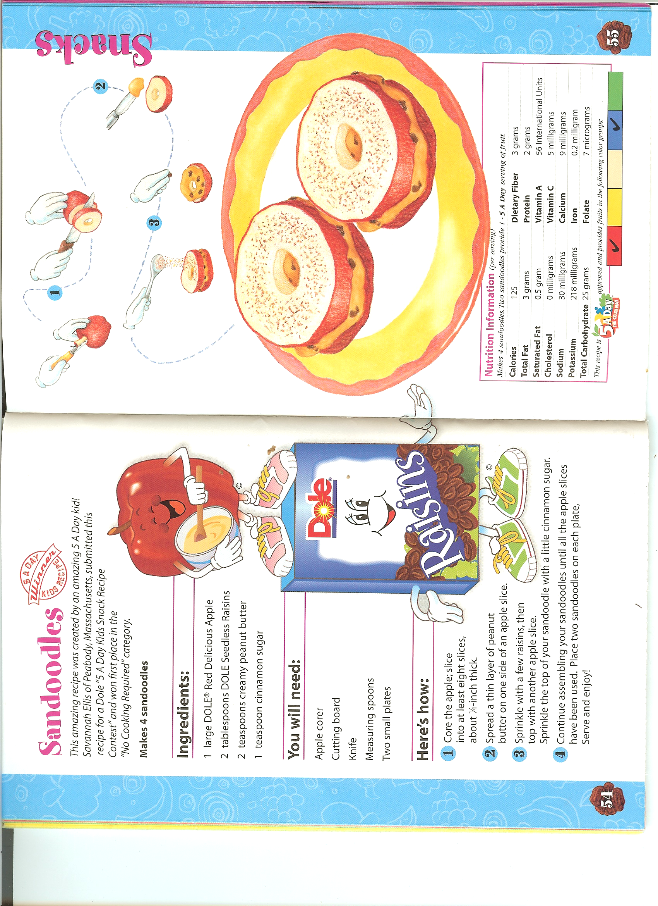

** KIDS’ KITCHEN **

**Home Link…** **Link…**

Reprinted from Dole’s

“5 A Day Kids Cookbook”

***NOTE:*** *If allergic to peanut butter --- substitute low fat cream cheese for peanut butter*

